Understanding how an Out-of-Home ad campaign improved brand identity for a cloud-based HR solutions company

Spreading an OOH advertising campaign doubled their organic search from the lowly single digits to historical highs

Improving brand perception and gaining notice requires time, promotional campaigns and great marketing ploys. This time let us analyze and understand the measurable value the OOH adverts made on how a Human Resource management firm left an indelible mark through positive organic social media reach.

### The Client: TriNet



Wallscape from TriNet Group, Inc

The client was a human resources management and recruitment firm for small to medium end businesses. In the already oversaturated recruitment sphere, the competition is high and it is very difficult to gain audience attention. Their main aim was to increase organic searches and promote a positive brand identity and stand out from the crowd.

### An advertisement strategy for high impact

TriNet mainly focused on spreading their service messages on crowded city blocks with Outdoor advertisement placements of standout wallscapes and creative bulletins at metro stations and they also utilized other subway media outlets. These OOH ads were placed on city centres to elicit maximum impact.

The adverts were mainly placed in three major US cities. They were placed in the urban capitals of New York, San Francisco and Los Angeles. As these cities showed a high influx of audience activity and the presence of professional employees(Trinet’s target demographic) it showed more promise for ROI(Return over Investment) for Impact.

### Creative excellence is crucial in building great campaigns

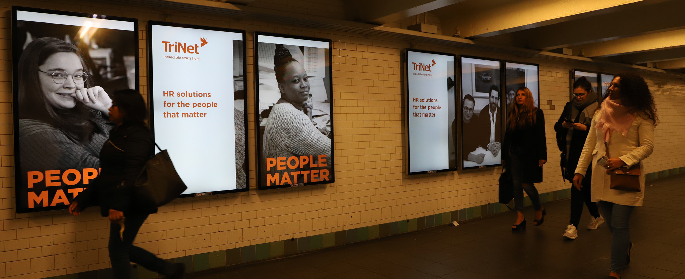

Metro station bulletins from TriNet Group, Inc

Contributing high quality talent for creative utilization is crucial in making great Out-of-Home adverts. Contrasting and unique bulletins are important to get an audience reaction. So, in order to get that TriNet hired the globally celebrated photographer Annie Leibowitz for capturing their campaign pictures. Their main goal was to incorporate humanity into their ad campaign.

They produced visually stunning real-life photographs of everyday people for their adverts and used different verticals of Outdoor advertisement placements.

### Unaided Organic search traffic boost with measurable impressions

The main aim of any campaign is in producing positive movement and changing the audience perception. American Marketing Association reports that there is a positive correlation between positive brand awareness and organic search rankings. Building on this, after their Outdoor Advertising deals, TriNet saw a net improvement of above 300% increase in organic audience awareness. This positive influx resulted in an improvement in all social media platform searches and the improvement in overall organic unaided awareness.

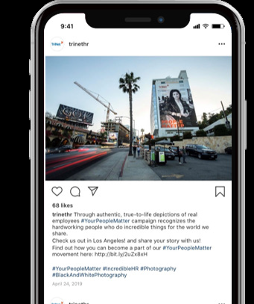

TriNet using social media platforms to intuitively push its Outdoor adverts campaign

Their brand and media voice also saw a significant uptick. Previously, TriNet had only minimal media voice; it increased its share to almost 30% from single digits. As a cherry on top, their brand reception scaled new heights with more than 97% recording positive media sentiment.

### The success of the OOH venture



Public bulletin from TriNet Group, Inc

The TriNet success shows us that through an integrated omni channel OOH campaign we are able to produce familiar, strong engagements that can scale up brand awareness and directly correlate to organic searches with measurable value. TriNet after their Outdoor Advertising success saw colossal improvements by subverting industry norms and also increasing marketing leads to double digits over their last quarter. This shows us the measurable success of an Out-of-Home advertisement in changing a company’s perceptions, organic searches and producing positive outreach.

All data analysed and used in this case study is credited to TriNet and Outfront Media.

**Bibliography**

Outfront Media and TriNet. (2019). *TRINET*. TRINET. https://www.outfrontmedia.com/inspiration/case-studies/trinet